SOR Polymorphizer
User Manual
Eliminate non-SOR attributes from OpenAPI / Swagger files using polymorphism
Application version 4.1
Desktop app · Command line · Batch runner

Contents

1. Introduction
The SOR Polymorphizer inspects an OpenAPI (Swagger) file and produces a new file in which attributes that have no System-of-Record (SOR) connection are removed, and shared schemas are refactored using OpenAPI polymorphism so that each operation carries only the fields it actually maps. The result is a cleaner contract with no empty, unmapped attributes.
It comes in three forms that all share the same engine, so results are identical whichever you use:
- Desktop app — a guided, three-step Windows window (the main tool for most users).
- Command line — for pipelines and scripted use.
- Batch runner — process many swaggers at once from a manifest.
Inputs. Each run uses the input swagger plus exactly one SOR mapping spreadsheet (the SOR Field column tells the tool which attributes map to the SOR). You may optionally attach one or more SOR API YAML files — the System-of-Record's own specs — which are used to validate that every mapped attribute's SOR field really exists in the SOR.

2. Key concepts
SOR connection. For every leaf attribute the mapping spreadsheet gives an SOR Field:
- a concrete value → the attribute is SOR-connected and is kept;
- “Not Used In SOR” or blank → not connected and is eliminated;
- absent from the sheet → no mapping exists, so it is eliminated (flagged “absent-from-mapping”).
Classes are never removed for lacking an SOR field. A node whose Data Type is object or array is structural; only its leaf attributes are eligible.
SOR YAML validation (optional). If you attach the SOR's own API YAML file(s), the tool collects every field name the SOR exposes and cross-checks the mapping. It reports which mapped SOR fields are confirmed present and which are not found (possible typo, rename, or stale mapping). This is a confidence check; by default it does not change what is eliminated.
Strict mode. Tick “Require SOR field to exist in SOR YAML” (or pass --require-sor-field) to also eliminate a mapped attribute whose SOR field is absent from the SOR YAML — turning “no field in the sheet” into the stronger “no corresponding field in the SOR contract.”
Polymorphism. Where two operations share a schema but need different subsets, the common part is factored into a base and each operation becomes allOf: [ base, { its own extras } ].
Discriminator. An optional selector on a generated base; its name is determined automatically during Analyze.
Inline de-duplication. An inline object identical to a named schema is replaced with a $ref.

3. Installation & building the Windows app

3.1 Install Python
Install Python 3.12 (64-bit) from python.org (3.10–3.13 all work). Two installer settings matter:
- tick “Add python.exe to PATH”;
- leave “tcl/tk and IDLE” checked (it provides the window).

3.2 Build the application
Extract the toolkit zip into a new, empty folder, then double-click:
build_windows_exe.bat
It installs dependencies, clears old caches, and produces dist\PolymorphizeSwagger.exe — a single file others can run with no Python install.
Verify the version: the title bar must read “SOR Polymorphizer v4.1”. If not, you launched an older .exe — use the one in the newly built dist folder.

4. Using the desktop app
The window guides you through three numbered steps (1 choose files → 2 Analyze → review boxes → 3 Run). Run stays disabled until you have analyzed.
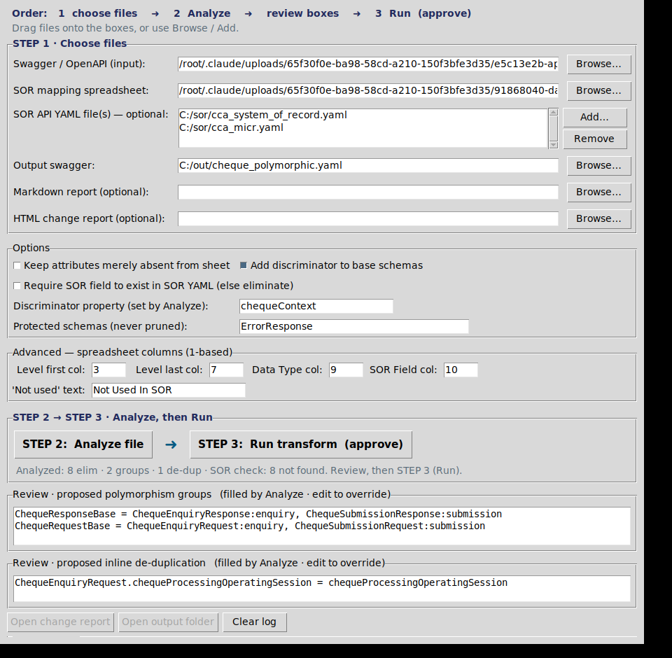
After STEP 2 (Analyze): one mapping spreadsheet, two optional SOR API YAML files, the proposal filled in, and “SOR check: 8 not found” in the status.

STEP 1 — Choose files
- Swagger / OpenAPI (input) — the file to transform.
- SOR mapping spreadsheet — exactly one spreadsheet.
- SOR API YAML file(s) — optional — attach the SOR's own spec(s) with Add… or by dropping them onto the list. Several are allowed. They validate the mapped fields (see §5).
- Output swagger, and optional Markdown / HTML reports. If HTML is blank, a report is still written next to the output as <output>_changes.html.

STEP 2 — Analyze
Analyze inspects the chosen files and fills in the proposed polymorphism groups, inline de-duplications, and the determined discriminator name for review. The log lists which attributes would be eliminated, and — if SOR YAMLs are attached — which mapped SOR fields were not found in the SOR.

STEP 3 — Run transform (approve)
Run shows an approval dialog summarising what will be written (including how many mapped fields were not found in the SOR). Nothing is written until you approve. Changing any input that affects the result invalidates the analysis and you must Analyze again.

4.1 Options
Option | Effect
Keep attributes merely absent from sheet | Only remove attributes explicitly Not Used In SOR / blank; keep ones simply not found in the sheet.
Add discriminator to base schemas | Add the determined selector (and mapping) to each generated base.
Require SOR field to exist in SOR YAML | Strict mode: also eliminate a mapped attribute whose SOR field is absent from the attached SOR YAML(s).
Discriminator property | Selector name; determined by Analyze, editable.
Protected schemas / Advanced columns | Schemas never pruned; and which spreadsheet columns hold the hierarchy, Data Type and SOR Field.

5. Understanding the changes
Every change is made visible three ways: inside the output swagger (a banner, an info.x-sor-polymorphizer record, and >>> CHANGE comments); the colour-coded application log; and the HTML change report shown below. When SOR YAMLs are attached, the report gains a validation section listing mapped fields that were not found in the SOR.
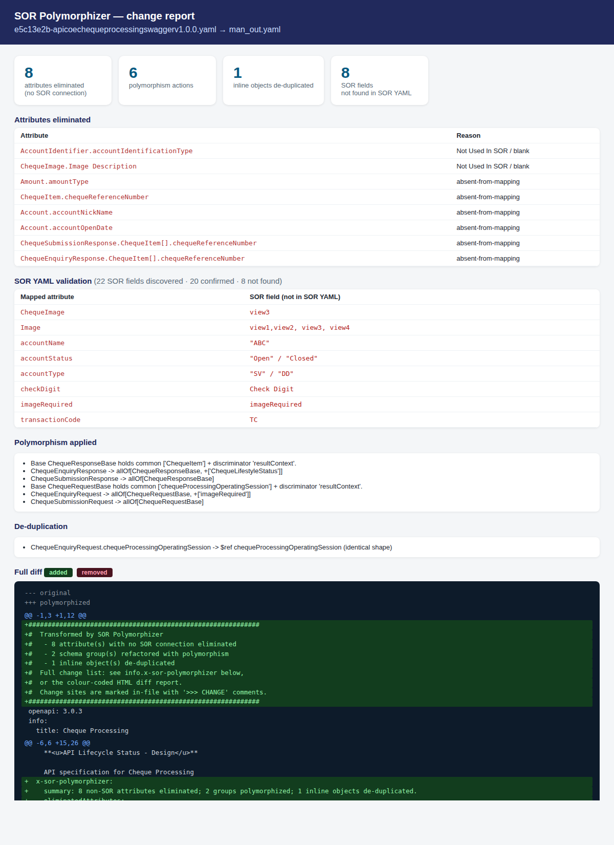
The HTML change report, including the SOR YAML validation section (mapped attribute → SOR field not found in the SOR).

6. Processing many swaggers (batch)
Drive large runs from a manifest — one job per row. Start from manifest_template.csv / .xlsx. Each row needs at least a swagger and one mapping spreadsheet.
SOR YAML in batch. The optional sor_swagger cell may list several SOR API YAML files separated by ;, and require_sor_field (true/false) turns on strict elimination for that row. Groups, de-dups and the discriminator are detected per file automatically; leave poly / dedupe blank unless overriding.
Run by dragging the manifest onto run_batch.bat, or:
python polymorphize_batch.py --manifest jobs.csv --jobs 4
It writes each transformed swagger and HTML report, plus batch_summary.csv and batch_index.html (a linked dashboard with totals and per-job status). --jobs N runs N in parallel; a failing file is reported and skipped.

7. Command-line usage
python polymorphize_cli.py \
--swagger cheque.yaml \
--mapping cheque_sor.xlsx \
--sor-swagger cca_system.yaml --sor-swagger cca_micr.yaml \
--out cheque_polymorphic.yaml \
--html-report changes.html --discriminator
Parameter | Meaning
--swagger / --out | Input OpenAPI file / output file.
--mapping | SOR mapping spreadsheet — exactly one.
--sor-swagger | SOR API YAML to validate mapped fields. Repeatable, or ;-separate.
--require-sor-field | Strict: eliminate mapped attributes absent from the SOR YAML(s).
--report / --html-report | Optional Markdown report / colour-coded HTML diff.
--discriminator / --disc-prop | Add a discriminator, and name it.
--auto-poly / --auto-dedupe | Auto-detect families / inline duplicates.
--poly / --dedupe | Explicit override(s) (repeatable).
--keep-absent / --protected | Keep absent-from-sheet attributes / schemas never pruned.

8. Troubleshooting
The old fields are filled in / behaviour looks old
You launched an old build. Check the title bar reads v4.1. Extract the zip into a NEW empty folder and rebuild — the build clears caches and prefers the newest source.
‘pyinstaller’ is not recognized
The build calls python -m PyInstaller, which does not depend on PATH. By hand: python -m PyInstaller …
“Script file 'polymorphize_gui.py' does not exist”
The Python files are still named *.py.txt. In Explorer, View > Show > File name extensions, and confirm they end in .py. The build auto-renames *.py.txt; extracting the zip avoids this.
I can't download the .py or .bat files
The app blocks script/executable extensions. Use the zip, or the .txt copies — rename to remove the trailing .txt.
Lots of ‘not found in SOR YAML’ warnings
Your SOR YAML(s) do not cover all the fields the mapping references — attach the full set of SOR specs, or ignore the warnings (they don't change the output unless strict mode is on).
Drag-and-drop does nothing
The optional tkinterdnd2 package is missing; the build bundles it. Meanwhile use Browse / Add.
Validation warns about a missing 'chequeprocessingid' path parameter
A pre-existing issue in the source swagger, not introduced by the tool.

9. Reference — manifest columns
Header row, case-insensitive. Unknown columns ignored; missing ones use defaults.
Column | Meaning (default)
swagger | input OpenAPI file (required)
mapping | SOR mapping spreadsheet — one (required)
sor_swagger | SOR API YAML(s) to validate; several separated by ; (optional)
require_sor_field | strict elimination using the SOR YAML (default: false)
out | output file (default: <swagger>_polymorphic.yaml)
report / html_report | Markdown / HTML report (html defaults next to out)
discriminator / keep_absent | add discriminator (true) / keep absent-from-sheet (false)
poly / dedupe | explicit override(s); blank = auto-detect per file
protected / level_* / dtype_col / sor_col / not_used_text | schemas never pruned; spreadsheet layout

SOR Polymorphizer v4.1 — user manual.

